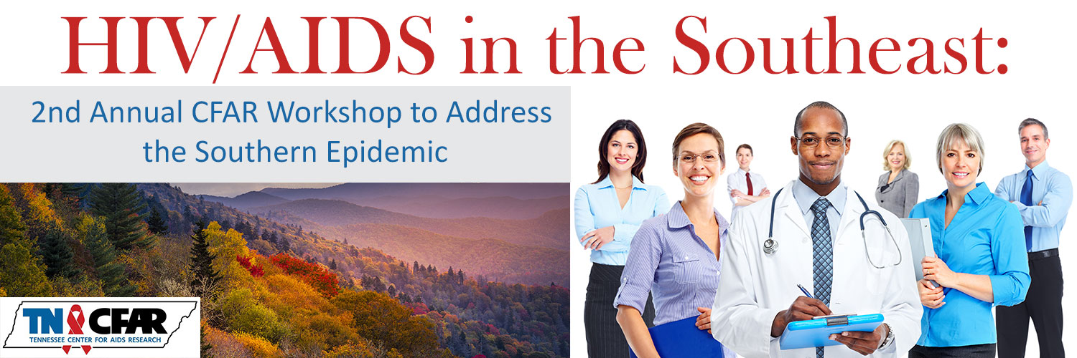
Meeting Evaluation Form ~ March 24, 2017
I. Program |  |  |  |  |  |  | NO! |  | SO-SO | YES!
Was the meeting well organized? |  |  |  |  |  |  | ○1 ○2 ○3 ○4 ○5
Were the topics relevant to you? |  |  |  |  |  |  | ○1 ○2 ○3 ○4 ○5
Were the presentations relevant to the overall workshop theme? |  |  |  |  |  |  | ○1 ○2 ○3 ○4 ○5
Comments on the program:
II. Speakers |  |  |  |  |  |  | NO! |  | SO-SO | YES!
Overall, were the speakers informative and understandable? |  |  |  |  |  |  | ○1 ○2 ○3 ○4 ○5
Were the speakers prepared? |  |  |  |  |  |  | ○1 ○2 ○3 ○4 ○5
Were the topics presented understandable? |  |  |  |  |  |  | ○1 ○2 ○3 ○4 ○5
Were the questions and discussion handled to your satisfaction? |  |  |  |  |  |  | ○1 ○2 ○3 ○4 ○5
Comments on the speakers:
III. Logistics |  |  |  |  |  |  | NO! |  | SO-SO | YES!
Was the workshop format conductive to open dialogue? |  |  |  |  |  |  | ○1 ○2 ○3 ○4 ○5
Were the session starting and ending times convenient? |  |  |  |  |  |  | ○1 ○2 ○3 ○4 ○5
Was your registration handled smoothly?  Was there adequate communication with you from organizers leading up to the workshop? |  |  |  |  |  |  | ○1 ○2 ○3 ○4 ○5
Comments on logistics:
IV. Taking it with you… |  |  |  |  |  |  | NO! |  | SO-SO | YES!
Did you gain insight into the current scientific research relevant to the Southern Epidemic? |  |  |  |  |  |  | ○1 ○2 ○3 ○4 ○5
Overall, was the workshop worthwhile? |  |  |  |  |  |  | ○1 ○2 ○3 ○4 ○5
Will you take action(s) on what you learned about the Southern Epidemic? |  |  |  |  |  |  | ○1 ○2 ○3 ○4 ○5
Did you network with others whom you expect to hear from in the future? |  |  |  |  |  |  | ○1 ○2 ○3 ○4 ○5
What are your overall comments, feedback, and realistic suggestions? Use back of sheet if necessary.
Optional: Please select the answer that best represents you:
Ethnicity: | ○ American Indian | ○ Alaska Native | ○ Asian |  | ○ Black or African American |  |  | ○ Hispanic
 | ○ Native Hawaiian or Other Pacific Islander |  |  | ○ White |  | ○ Two or More Races
I identify my gender as: __________________
Thank you for your participation in this HIV / AIDS in the Southeast Workshop and Evaluation Form!

